Ultrasonically Recovered Performance of γ-irradiated Metal-Silicon Structures

A. M. Gorb, O. A. Korotchenkov, O. Ya. Olikh, A. O. Podolian

Abstract - The MHz-frequency ultrasound treatment is shown to offer a recovery tool in the current–voltage (I–V) characteristics of the γ-irradiated metal-silicon structures. It is shown that about 30% of the Schottky diode currents and free carrier lifetimes worthen by the irradiation could be recovered in the stress field of ultrasound. The likely scenario behind the treatment effect is outlined, implying the involvemt of the vacancies released from the E-centers and subsequently trapped at the Si-SiO₂ interface.

Index Terms – Ultrasound, radiation, silicon, defects, lifetime.
I. Introduction

SILICON is widely used in radiation detectors and electronic devices and numerous fields of application imply adverse radiation environments that may affect the operation of the devices [1]. Metal–semiconductor Schottky diodes are particularly sensitive to high-level radiations, e.g., to ⁶⁰Co γ-rays [2, 3]. The formation of lattice defects in the form of vacancies, defect clusters and dislocation loops near the metal–semiconductor interface caused by the irradiation is very harmful for device performance since these defects can act as recombination and trapping centres for charge carriers. Therefore, it is of special interest to develop reliable techniques capable of reducing the number of the electrically active damage defect centers introduced by irradiation. Elevated temperatures are commonly employed in the defect annealing techniques which inherently pose serious problems of generating thermal donor centers (see [4] and references therein), contaminating a semiconductor in the metal–semiconductor structure due to diffusion of the metal contact material etc.
The treatment of Si with ultrasound (ultrasound treatment, UST) was shown to offer a nearly room-temperature annealing of radiation defects [5-8] paving an alternative way to improve the performance of silicon-based devices for particle physics experiments, nuclear medicine and space. A lot of effort has been put into the exploitation of the UST technique in order to engineer and to recover defect-related electronic parameters of silicon [9, 10].
The authors are with the Faculty of Physics, Taras Shevchenko Kyiv National University, Kyiv 01601, Ukraine, E-mail: olegk@univ.kiev.ua
The ultrasound treatment utilized in this work was purpose-built to facilitate the UST concept as a recovery tool in the current–voltage (I–V) characteristics of the γ-irradiated metal-silicon structures. The next purpose of this work was to introduce the relevant mechanism driving the observed evolution of the I–V characteristics. Understanding of UST effects on irradiated metal–silicon structures would have an impact on the design of the diode devices allowing the development of a specific method for an enhanced radiation stability of these types of semiconductor devices.

II. Experimental

EXPERIMENTS were performed on n-type (111)-oriented crystalline FZ-Si with residual B impurity concentration of about 10¹² cm⁻³ and doping P impurity concentration of 2×10¹² cm⁻³. The corresponding resistivity is ≈ 4 kΩ⋅cm. A bulk silicon material was divided into several rectangular-shaped samples of approximately 1×5×10 mm³. One of the samples was used as the reference materials, the other ones were γ-irradiated (⁶⁰Co source) at nominal room temperature to the dose ranged from 5×10⁶ to 5×10⁷ rad. The resulting conductivity of the samples was reduced to about 0.5 of the initial value. They were found to remain n-type at all irradiation doses used.
The sample geometry is sketched Fig. 1. The Schottky barrier structures, used in the current-voltage (I–V) measurements, were prepared by chemical etching of the upper Si surfaces using HF-HNO₃-CH₃COOH solutions (HF: HNO₃: CH₃COOH =3:5:3), followed by the surface oxidation due to the exposure to ambient air for 24 hours and the Au vacuum evaporation. GaZn-eutectic Ohmic contacts were rubbed on the bottom surfaces of the samples. A metal-oxide-semiconductor (MOS) device was consequently formed. For the photocurrent (PC) decay measurements, GaZn Ohmic contacts were rubbed on the top and bottom contact layers. The area of the upper contact was ≈ 50 mm² in all cases.

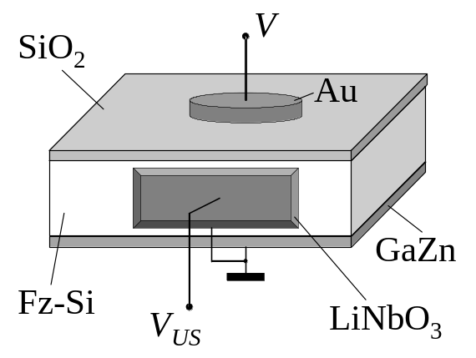
Fig. 1. Schematics of the investigated structure.

In this work, ultrasonic treatment (UST) techniques were used to recover defect-related electronic parameters of the irradiated samples. This was done by attaching the LiNbO₃ piezoelectric transducer to one side of the sample, as shown in Fig. 1. An epoxy glue was used as the bonding medium, providing the rigid coupling of the transducer to the sample. The thickness resonant frequencies (f) of the transducers ranged from 3 to 4.1 MHz. An rf voltage supplied from a generator drives the transducer, resulting in vibrations of the coupled transducer-sample system. The rf strain is then produced in the semiconductor allowing to mechanically modify the electronic properties of the material.
The density of acoustic energy flux (W_{US}) in Si was estimated by neglecting the mechanical loses in the transducers, 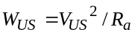, with 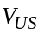 the rf voltage amplitude applied to the transducer and 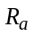 the resistance of an acoustic irradiation. The value of can be expressed as
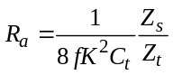, (1)
where K is the coefficient of electro-mechanical coupling of the transducer, 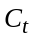 is its capacitance, 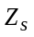 and 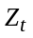 are the impedance of the sample and the transducer, respectively. This gave W_{US} ≈ 2 W/cm², yielding the strain amplitude inside the sample of about 10⁻⁵.
The sample temperature was measured with a copper–constantan thermocouple directly attached to the sample surface. Ultrasonic treatment was carried out by a series of consecutive loading-unloading cycles, 30 min each. The sample surface temperature raise did not exceed 350 K at the greatest W_{US} used over the course of the loading cycle.
The characteristics of the Au/Si Schottky barrier diode, after γ–irradiation and after UST, were investigated using an I–V measurement technique. For this purpose, computer-driven system based on the analog-to-digital converter ADA-1282 was used. This setup allows to measure forward and reverse bias I–V characteristics for the current varied in the range from 3×10⁻¹⁰ to 10⁻³ A with a voltage step of 0.01 V.
In order to relate the observed I–V changes to defect annealing processes, the photocurrent transient decays were additionally studied before and after ultrasonic treatments. These were taken using a pump pulse generated by a 1.06-μm light-emitting diode (LED) with a half-width of 50 nm. The LED beam that excites the sample was expanded to achieve nominally uniform illumination on the sample surface. The LED was controlled by the external bias in the form of square-function pulse. Light pulse lengths of 100 μs were used, with rise and fall times of ≈ 1.2 μs. The LED pulse sequence had a period of about 50 ms, which was substantially greater than the PC decay time. The background noise level was obtained by averaging the decay signal in the relaxed transient range. The light pulse intensity was controlled so that the low-level injection conditions were satisfied (the injected carrier concentration was 1% of its steady value). Decay transients were stored in the computer memory using an analog-to-digital converter with a resolution of ≈ 2 μs. RC time constants were observed to be less than 100 ns, which was much smaller than the time scales of interest.
The heat treatments were carried out by isochronal anneals at temperatures ranging between 350 and 530 K in a quartz-tube furnace under ambient conditions.

III. Resuls and Discussion

A. A brief introduction to currier transport mechanisms

Due to the presence of surface or interface states in the band gap of a semiconductor, the Fermi level at the surface (or interface) may have a different position with respect to the band edges than in the bulk. At thermal equilibrium, the Fermi level is constant throughout the crystal, thus yielding a charge transfer between surface and bulk. Consequently, the surface is charged with the charge value which is balanced by an opposite space charge in a layer underneath the surface. Assume that the energetic position and occupancy of the surface states within the band gap is such that the charge transfer depletes the subsurface layer of majority carriers. Then the charge distribution produces an electric field within the space charge region and a corresponding band bending, which can be obtained from Poisson’s equation and is shown in Fig. 2. The thickness l of the depletion layer is

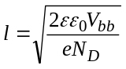, (2)

where V_{bb} is the magnitude of the band bending, N_{D} is the bulk dopant concentration, ε is the dielectric constant, ε₀ is the dielectric constant of free space and e is the electron charge.

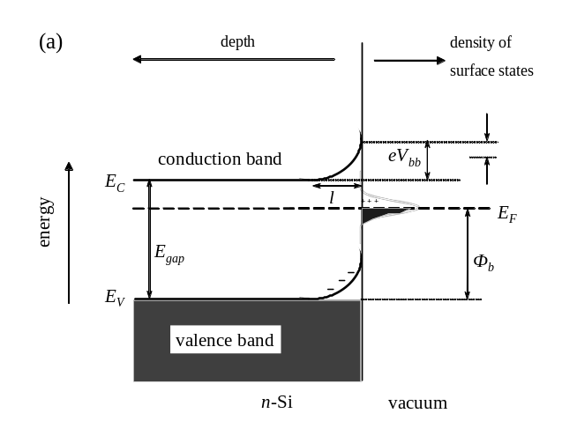
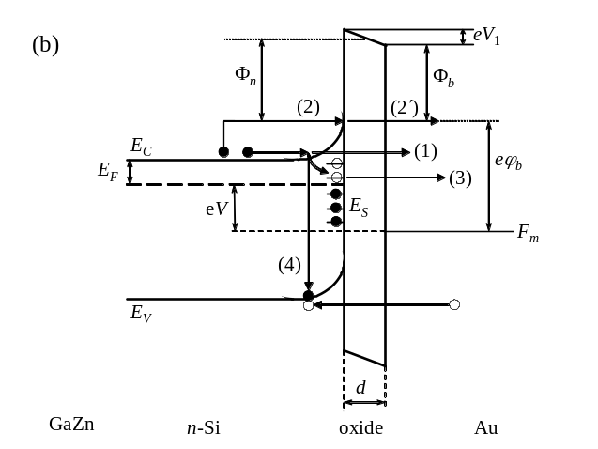

Fig. 2. Band diagrams of MOS devices: (a) in equilibrium, in the absence of the insulating layer, (b) at externally applied voltage V, with the oxide layer of the thickness of d. The diagrams illustrate the band bending V_{bb} in the subsurface region of an n-doped semiconductor which have surface states within the band gap. Φ_{b} is the Schottky barrier height, Φ_{n} is the mean barrier height, E_{F} and F_{m} are the Fermi levels in Si and Au, respectively, 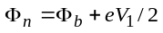. Each of the horizontal lines E_{S} in (b) represents an interface trap. It is either occupied by an electron (solid circle) or occupied by a hole (open circle). Arrows (1)-(4) represent the main currier transport mechanisms discussed in the text. На (а) там ли Φ_{b} ??? И что за стрелки без символа вверху справа ??? На (b) – наклон на оксиде в другую сторну ??? Там ли показано eϕ_{b} , возможно, от Е_{С} до стрелки (2)???

The density of a dark current I, flowing between metal and semiconductor, in the n-type semiconductor-based MOS device under a forward bias is as follows [11]

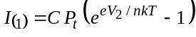, (3)

where 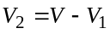 is the voltage drop across the space-charge (depletion) region of the ??? (иначе зачем вводить 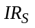 в (4)) semiconductor, V is the bias voltage applied to the top metal electrode (cf. Fig. 1) with respect to the semiconductor, V₁ is the voltage drop across the insulating oxide layer, n is the ideality factor, k is the Boltzman constant, T is the temperature, P_{t} is the carrier transfer probability through the insulating layer, and C is a coefficient.
Furthermore, in the more general case, the current is limited by the series resistance, which is due to the contact resistance between the metal and the semiconductor, the resistance of the thin insulating layer, the resistance of the semiconductor or the series resistance of the connecting wires. Since, in high-resistivity Si, the resistance of the semiconductor R_{S} cannot be neglected, the bias voltage V is

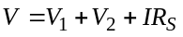, (4)

where is the voltage drop across the quasi-neutral region of the semiconductor, extended beyond the space-charge (depletion) убрать красное, если оставить его после ф-лы (3) region of width l in Fig. 2(a).
In case of the quantum mechanical tunneling through the Schottky barrier and the insulating layer [process (1) in Fig. 2(b)] the probability P_{t} is

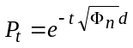 (5)
and
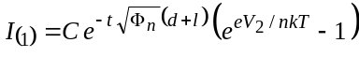 (6)
where t is the tunneling constant which is 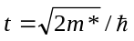, m* is the effective electron mass in SiO₂ (∼0.5m₀), m₀ is the free electron mass, and is the Planck constant. The ideality factor n = 1 if the recombination-generation current developed due to band-to-band recombination/generation [process (4) in Fig. 2(b)] is unimportant, and 1 < n < 2 otherwise.
Since the doping concentration in our samples is low (≈ 10¹² cm⁻³), the width of the depleted region l, obtained from Eq. (1), is large enough, of about 20 μm (проверено ???). Then there is hardly the Schottky barrier to tunnel through, and the migration pathway sketched by process (1) in Fig. 2(b) is likely to be avoided by the carrier in favor of an easier route (2)–(2′).
Overcoming the Schottky barrier by process (2) in Fig. 2(b) can be described in the thermionic emission model, and the coefficient C is given by

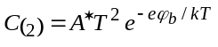, (7)

where 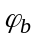 is the Schottky barrier height in the semiconductor for the MOS region (ϕ_{b} , возможно, от Е_{С} до стрелки (2) in Fig 2 ???) and A* is the modified Richardson constant. Then the total current transmitted through the processes (2) and (2′) is

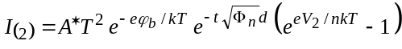. (8)

If pathway (2)–(2′) in Fig. 2(b) is the dominant process, the mean barrier height Φ_{n} at the silicon-oxide interface can be calculated from the slope of the semilog 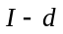 plot. If 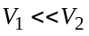, the logarithmic plot of I/[1-exp(-eV/nkT)] against V is linear. In this case, 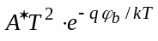 can be obtained from the I-axis intercept at zero V, and from this the barrier height can be derived.
The effect of tunnelling through the interface states E_{S} [process (3) in Fig. 2(b)] can be achieved by introducing the density D_{S} of the interface states, which are evenly distributed in the energy range ΔE_{S}, the capture cross-section σ_{St} of the interface states for tunnelling, and the occupational probability f_{S} of the interface states. In this process, the electrons, captured at the interface states [curved arrow in Fig. 2(b)], tunnel from these states to vacant states in the metal (Au). A backward tunnelling of electrons from the metal to the interface states should also be taken into account. Then the current is [12]

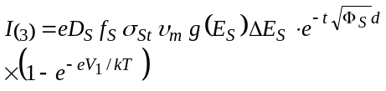, (9)

where 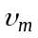 is the thermal velocity of electrons in the metal, 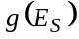 is the density of states in the metal at the energy of E_{S}, and Φ_{S} is the barrier height for electrons captured at the interface states.
Obviously, in the general case, the current through the MOS device is equal to the algebraic sum of 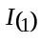, 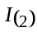 and the current 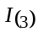 due to tunnelling via the interface states. This, of course, complicates the analysis of the measured I–V curves.

B. Current–voltage characteristics

Figure 3 shows the semilogarithmic plots of the forward- and reverse-bias I–V characteristics of one of the MOS structures, taken before and after γ-irradiation (solid and open circles, respectively). It is seen that the plot taken before γ-irradiation consists of a good linear range with a well-defined intermediate-bias region followed by the current saturation. In contrast, the intermediate-bias region with different slopes is achived in the irradiated sample at much lower voltages, thus making a linear range less pronounced and decreasing substantially the value of the saturation current.
These experimental results can be interpreted in the light of the above models. The forward I-V curves shown in Fig. 3 can be analyzed using the Schottky barrier thermionic emission model, so that

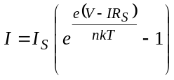, (10)

which is derived from (8) under the simplifying assumption that (так ли ???) and introducing the saturation current 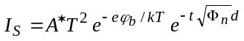.

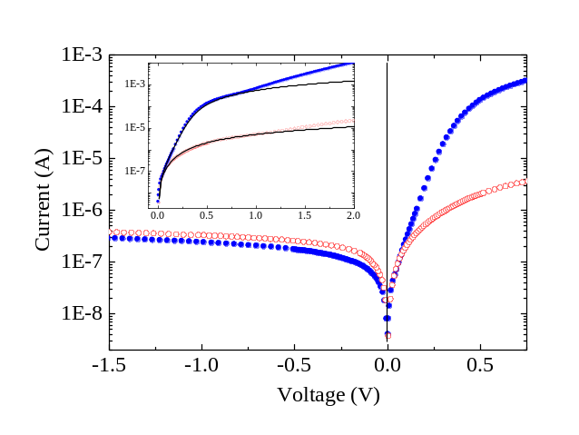

Fig. 3. The reverse and forward I-V curves of the Au-SiO₂-Si Schottky barrier structure taken before (solid circles) and after (open circles) γ-irradiation. T = 295 K. Inset enlarges the forward bias region, the solid lines are the fitting curves calculated by using (10) with I_{S} = 5×10⁸ A ???, R_{S} = 10³ Ω (upper curve) and 1.5×10⁵ Ω (lower curve).

The results of simulations shown by solid curves in the inset of Fig. 3 reveal a very good correspondence between the measured and computed I–V characteristics at V ≤ 1 V, with the discrepancies which arise at greater voltages. Within a schematic picture shown in Fig. 2(b) this result may be interpreted such that two different processes (2) and (2′) are present in the electron pathway. Indeed, the current saturation is achieved at the condition when the V-dependent resistance of the depleted region approaches the sum of R_{S} and the resistance of the oxide layer, which is achieved at about 0.4 V in the pre-irradiated sample. As the applied voltage V increases above ≈ 1.6 V, the charge density at the interface becomes so high that it leaks through the oxide by Fowler–Nordheim or direct tunneling mechanism, which can be described by [13]
Φ_{n} ли барьер ???
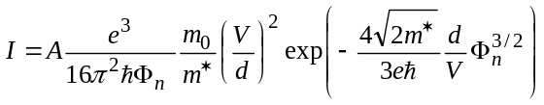, (11)

where A is the tunneling area. It is observed that the Fowler–Nordheim plot of 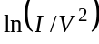 vs 1/V clearly exhibits a linear relationship above ≈ 1.6 V. Therefore, the above discrepancies can be due to electron tunneling at a large bias, which subsequently increases the measured current.
Since the irradiation causes the increase in the sample resistance R_{S}, the saturation condition, 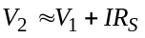, is achieved at a lower voltage V, applied to the structure. This leads to a decrease in the saturation current in the irradiated sample, as observed both experimentally and theoretically in Fig. 3.

При обратном смещении при V > 1 В 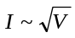, что свидетельствует о преобладании рекомбинационного механизма (процесс 4 на рис.2(b)) в протекании тока. В результате облучения концентрация центров захвата увеличивается, время жизни свободных носителей уменьшается, что и приводит к увеличению обратного тока, которая наблюдается на рис. 3.

Кусок про действие УЗ.
После УЗО наблюдается увеличение тока при прямом смещении, особенно оно велико при небольших значениях V. Это можно объяснить увеличением величины С₍₂₎ (формула (7)) благодаря уменьшению высоты барьера Шотки ϕ_{В} в результате действия УЗ. А именно, в акустическом поле происходит диффузия радиационных дефектов на стоки, в роли которых может выступать поверхность раздела полупроводник-диэлектрик. Как следствие, после УЗО увеличивается величина Ds. В свою очередь, аccording to Bardeen’s Fermi level pinning model [14, Sze], if the interface density Ds is very high, the Schottky barrier height on an n-types semiconductor is given by
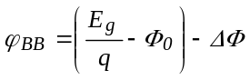, (10)
where Eg is the band gap of the semiconductor, qФ₀ is the energy level coincident with the Fermi level before the MS contact was formed and ΔФ is the lowering of the Schottky barrier due to the image force. It being of the order of 0.01eV may be neglected. On the other hand, when Ds is zero, then the barrier height of a Schottky barrier diode on an n-type semiconductor is given by

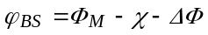, (11)

where Ф_{М} is the work function of the metal and qχ is the electron affinity of the semiconductor. According to Sze [14], the estimated values of 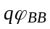 and 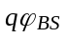 are 0.82 ± 0.36eV and 1.05 ± 0.36eV, respectively. This means that when the interface state density D_{S} increases from the Schottky limit to the Bardeen limit, the barrier height should decrease.

We first present the I-V characteristics of the irradiated structures in the temperature range of 290-330 K, indicative of the charge transfer mechanisms occurring in our samples. The results will serve as a reference for the UST study, especially in relating defects with specific regions within the Au-Si structure.
Fig. 1(a) shows the forward I-V dependence taken in the irradiated sample. The dependence of forward current I_{F} on forward-bias voltage V_{F} for small bias (U_{F} < 1 V) is well described by assuming a power-law dependence
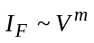, (2)
where m is the temperature-dependent coefficient, which increases with increasing V_{F} and falls into the range of 1−1.8.
Based on previous studies, such a dependence implies conditions of the space charge limited current through the barrier [11, 12]. The observed value of m indicates that the intermediate mode between the linear Ohmic mode and the quadratic trap mode is realized in this case, so that the density of the injected carriers is greater than that of the thermo-activated carriers [11, 12]. Indeed, assuming that (i) the width of the space charge region is about 30 μm for the barrier height of 1 eV, as obtained from the Schottky-barrier approximation, and (ii) the bias voltage drops over the high-resistance space charge region, the estimated current density of the thermo-activated carriers is about 5 mA/m². In contrast, the observed density is about 10 mA/m².
Further increasing V_{F} above ≈ 2 V yields increase of the slope of the I–V curve to a value near 2, indicative of the fact that the non-trap quadratic mode arises. The density of the injected carriers is greater than the one of the initially unoccupied traps, so that the current mode changes [11,12]. At V_{F} > 2.5 V the I–V dependence is dominated by the influence of the semiconductor series resistance with the total voltage drop across this resistance.
The activation energy Е_{А} of the current at V_{F} < 1 V is obtained from the slope of the Arrhenius plot of 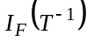 shown in Fig. 2(a) giving the value of 0.33 eV, which was previously attributed to traps located in the depleted layer [12]. The origin of these traps may be due to dangling bonds of Si atoms at the Si-SiO₂ interface produced by γ-irradiation [13]. Both the activation energy (0.33 eV) and the irradiation dose (from 1 to 5×10⁶ rad) producing the traps which were reported in Ref. [13] are very close to our values, thus implying these traps predominantly affect the current in our structures.
Reverse-bias current–voltage characteristics are shown in Fig. 1(b). At bias voltages smaller than 0.1 – 1 V, depending on the temperature, a nearly linear dependence (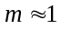) is observed. Clearly, upon increasing V_{R} the density of the carriers injected from the metal contact drops leading to the 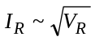 (m = 0.5) dependence observed at V_{R} > 1 V. From the slope of the Arrhenius plot shown in Fig. 2(b) the current activation energy Е_{А} = 0.68 eV is obtained in this case. The value of m indicates that the generation-recombination process determines the current mechanism. Then [14]
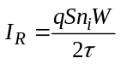, (3)
where n_{i} is the charge carrier concentration in the intrinsic semiconductor, W is the width of the depleted region (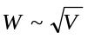) and is the carrier lifetime in the depleted region.
Both the forward and reverse I–V characteristics in the irradiated samples are different with respect to those of a non-irradiated diode. На Рис.0 приведены характеристики структур метал-кремний, созданные на основе starting material. При прямом смещении при V_{F}<0.4 V кривая хорошо описывается выражением (8) при 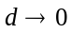. Из наклона полулогарифмической зависимости I=f(V) была определена величина коэффициента неидеальности n ≈ 1.7, что говорит о большом вкладе в ток рекомбинационно-генерационных процессов, то есть о наличии существенного количества рекомбинационных центров вблизи перехода. При V_{F} >1.6 V вольт-амперная характеристика становится линейной в координатах Фаулера-Нордгейма (Fowler-Nordheim) – см. рис.0 (b) - что свидетельствует о туннельном механизме прохождения тока при больших прямых смещениях. Так как величина приложенного напряжения в целом невелика, то, по нашему мнению, туннелирование в данном случае может проходить при участии энергетических уровней, расположенных в запрещенной зоне полупроводника и связанных с дефектами в области барьера. То есть, наличие данного участка также косвенно подтверждает присутствие нарушений кристаллической решетки. Обратные характеристики (рис.0 (с)) по характеру совпадают с таковыми для структур, созданных после облучения кремниевых пластин, но в данном случае характеризуются несколько меньшим значением величины тока. Коэффициент выпрямления 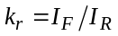 составил величину 260 при V=0.35 V.
Таким образом, в структурах металл-полупроводник, созданных на основе облученных пластин Si благодаря увеличения в них количества дефектов наблюдается изменение характера (при прямом смешении) и величины тока, что, в частности, привело к уменьшению 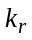.

B. Influence of UST

The effect of UST on the I–V characteristics is shown in Fig. 3. It is seen that ultrasound has a profound effect on both the forward and reverse currents (panels a and b, respectively), whereas the I–V curve shapes remain nearly unchanged. Summarizing the UST results allows to conclude that (i) the forward resistance of the structure decreases remarkably, about one order of magnitude, (ii) after applying UST for a sufficiently long time the I–V characteristics is dominated by a single-slop line indicative of a non-trap quadratic mode, as seen in curve 3 of Fig. 3(a), (iii) after UST, the reverse I–V characteristics are transformed into the form of a dependence at larger bias voltages, greater than ≈ 0.7, 1.3 and 2.2 V in curves 1, 2 and 3 of Fig. 3(b), respectively, (iv) the reverse current drops substantially after UST, as evidenced by comparing curves 3, 2 and 1 in Fig. 3(b), and (v) the m value in the exponent gradually increases at the initial stage of the reverse I-V characteristics.
Clearly, the two items (i) and (iv) indicate a significant increase in the rectification factor 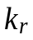 of the structure; see data of Table 1. Moreover, because the magnitude of 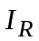 is inversely proportional to τ for the case [see Eq.(3)], an implicit assumption in the reverse current drop in (iv) is that the carrier lifetime increases by UST. This is documented by the data of 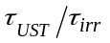 given in Table 1. This latter is furthermore supported by taking the photocurrent transient decays displayed in Fig. 4. It is seen that γ-irradiation remarkably reduces the carrier lifetime (cf. 500 μs obtained from curve 1 and 77 μs from curve 2 in Fig. 4). In turn, UST increases the lifetime which is manifested by a slowing down the decay curves 3-5 in Fig. 4. This increase in is indirectly confirmed by item (v), which implies that τ gradually approaches the value of the electron transport time through the depleted layer [11].
Weighing the results given in items (ii) and (iii), it has to be concluded that UST is capable of reducing the trap concentration because curve 3 in Fig. 3(a) is dominated by a non-trap characteristic line [11]. Next, a larger voltage range supporting the space charge limited current mode with increasing the duration of UST may be due to the fact that the influence of the impurity centers becomes greater due to the relative decrease of the radiation defect concentration, thus enlarging the reverse bias voltage which transforms the I–V characteristics into the generation-recombination mode.
Based on the facts given above, the following scenario describing UST may be applicable. It has been evidenced previously by several authors that the above-barrier defect displacements become feasible with ultrasonic treatments [9, 15-17]. The thermal annealing of our samples showed that the dominant irradiation-induced defect in the structures is the E center containing the vacancy (V) and the P atom. Then the lifetime enhancement and the subsidiary effects of UST on the I–V characteristics given above can be understood at least in general terms as due to release of vacancies from the E-centers and their subsequent trapping at defect sinks. Based on the above evidence, it can be proposed that the dominant defects following UST are V and P, the former being locked to electrically inactive configurations at the Si-SiO₂ interface. In order to provide the additional information concerning the microscopic nature of the defects featuring in UST, there is a need for further efforts combining DLTS, EPR and infrared absorption techniques.

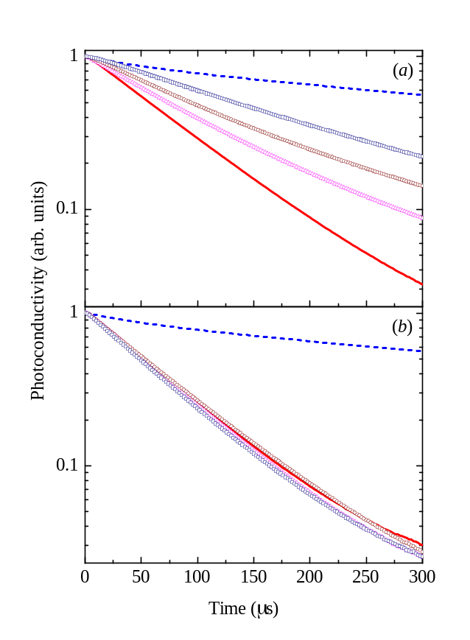

Fig. 5. Photocurrent transient decays taken before (dotted lines) and after (solid lines) γ-irradiation (5×10⁶ rad), and after ultrasound (a) and thermal (b) treatments of the irradiated sample. UST is performed at acoustic power of ≈ 2 W/cm² and frequency of 3 MHz during 60 (triangles), 120 (circles) and 240 (squares) min. Thermal treatment is performed at 360 K during 30 (triangles), 90 (circles) and 150 (squares) min. The surface recombination velocity is kept constant at about 10³ cm/s. The carrier lifetime τ = 500 (1), 77 (2), 100 (3), 119 (4) and 177 μS (5).

IV. Conclusion

A partial recovery of the current–voltage characteristics and photocurrent transient decays are achieved in γ-irradiated silicon by using a room-temperature ultrasonic treatment. A detailed analysis of the I–V characteristics in the metal-silicon structures before and after UST is performed. It is shown that roughly 30% of the irradiation-damaged forward and reverse currents and carrier lifetime could effectively be recovered. The effect can be related to a low-temperature annealing of radiation defects in the ultrasound stress fields, and the release of vacancies from the E-centers with their subsequent trapping at the Si-SiO₂ interface is particularly envisaged.

IV. Conclusion

A partial recovery of the current–voltage characteristics and photocurrent transient decays are achieved in γ-irradiated silicon by using a room-temperature ultrasonic treatment. A detailed analysis of the I–V characteristics in the metal-silicon structures before and after UST is performed. It is shown that roughly 30% of the irradiation-damaged forward and reverse currents and carrier lifetime could effectively be recovered. The effect can be related to a low-temperature annealing of radiation defects in the ultrasound stress fields, and the release of vacancies from the E-centers with their subsequent trapping at the Si-SiO₂ interface is particularly envisaged.

References

[1] C. Leroy and P.-G. Rancoita, “Particle interaction and displacement damage in silicon devices operated in radiation environments,” Rep. Prog. Phys., vol. 70, pp. 493–625, Apr. 2007.
[2] Ş. Karataş, A. Türüt, and Ş. Altındal, “The timing performance of a two-dimensional position-sensitive silicon detector,” Nuc. Instr. and Meth. A, vol. 555, pp. 260–266, Dec. 2005.
[3] P. Jayavel, M. Udhayasankar, J. Kumar, K. Asokan, and D. Kanjilal, “Electrical characterization of high energy ¹²C irradiated Au/n-GaAs Schottky Barrier Diodes,” Nuc. Instr. and Meth. B, vol. 156, pp. 110–115 , July 1999.
[4] R. C. Newman, “Defects in silicon,” Rep. Prog. Phys., vol. 45, pp. 1163–1210, Oct. 1982.
[5] I. V. Ostrovskii, O. A. Korotchenkov, and V. A. Lysykh, “Ultrasonic annealing of point defects in solids,” Sov. Phys. Solid State, vol. 29, pp. 1239–1240, July 1987.
[6] A. A. Podolyan and V. I. Khivrich, “Room-temperature ultrasonic annealing of radiation defects in silicon,” Tech. Phys. Lett., vol. 31, pp. 408–410, May 2005.
[7] N. A. Guseynov, Ya. M. Olikh, and Sh. G. Askerov, “Ultrasonic treatment restores the photoelectric parameters of silicon solar cells degraded under the action of ⁶⁰Co gamma radiation,” Tech. Phys. Lett., vol. 33, pp. 18–21, Jan. 2007.
[8] O. Ya. Olikh and T. N. Pinchuk, “Acoustic wave corrected current-voltage characteristics of GaAs-based structures with Schottky contacts,” Tech. Phys. Lett., vol. 32, pp. 517–519, Jun. 2006.
[9] S. Ostapenko, N. E. Korsunskaya, and M. K. Sheinkman, “Ultrasound Stimulated Defect Reactions in Semiconductors,” Solid State Phenom., vol. 85–86, pp. 317–36, 2002.
[10] S. Ostapenko, L. Jastrzebski, J. Lagowski, and R. K. Smeltzer, “Enhanced hydrogenation in polycrystalline silicon thin films using low-temperature ultrasound treatment,” Appl. Phys. Lett., vol. 68, pp. 2873–2875, May 1996.
[11] H. Kobayashi, T. Ishida, Y. Nakato, and H. Mori, “Mechanism of carrier transport through a silicon-oxide layer for ⟨indium-tin-oxide/silicon-oxide/silicon⟩ solar cells,” J. Appl. Phys., vol. 78, pp. 3931–3939, Sept. 1995.
[12] S. Biswas and A. Mansingh, “Influence of surface states on current-voltage characteristics of M-I-pSi solar cells”, J. Phys. D: Appl. Phys., vol. 25, pp. 100-105, Jan. 1992.
[13] A. Olbrich, B. Ebersberger, and C. Boit, “???????????????”, Appl. Phys. Lett., vol. 73, pp. 3114-????, ???. 1998.

[11] M. A. Lampert and P. Mark, Current Injection in Solids, New York and London: Academic Press, 1970.
[12] A. A. Sherchenkov, B. G. Budagyan, and A. V. Mazurov, “The mechanisms of current transport and properties of a-SiC:H/c-Si heterostructures,” Semiconductors, vol. 39, pp. 928–933, Aug. 2005.
[13] P. B. Parchinskii, S. I.. Vlasov, and A. A. Nasirov, “The effect of γ-ray radiation on the characteristics of the interface between silicon and lead-borosilicate glass,” Semiconductors, vol. 38, pp. 1304–1307, Nov. 2004.
[14] S. M. Sze, Semiconductor Devices, Physics and Technology, NewYork: Wiley, 1985.
[15] I. V. Ostrovskii, O. A. Korotchenkov, T. Goto, and H. G. Grimmeiss, “Sonoluminescence and acoustically driven optical phenomena in solids and solid–gas interfaces,” Phys. Rep., vol. 311, pp. 1–46, Jan.1999.
[16] Ya. M. Olikh, M. D. Tymochko, and A. P. Dolgolenko, “Acoustic-wave-stimulated transformations of radiation defects in γ-irradiated n-type silicon crystals,” Tech. Phys. Lett., vol. 32, pp. 586–589, Jul. 2006.
[17] O. Ya. Olikh, and I. V. Ostrovskii, “Ultrasound-Stimulated Increase in the Electron Diffusion Length in p-Si Crystals ,” Phys. Solid State, vol. 44, pp.1249–1253, Jul. 2002.
[18] .
[19] .
[20] .
[21] .

